**D.A.V. PUBLIC SCHOOL**

**PALAMPUR (H.P.)**

**A PROJECT REPORT**

on



Language used: C++

Submitted To: Mrs. Meenu Katal

Submitted by-

Akshit Sharma

Class – XII (B)

Roll no.______________

Accompanied by-

Rohan Paharia

Roll no.______________

INDEX

|  |  |  |
| --- | --- | --- |
| **Sr. No.** | **Title** | **Page Range** |
| **1** | Acknowledgement | 3 |
| **2** | Certificate | 4 |
| **3** | Introduction | 5 |
| **4** | Flow of Control | 6 |
| **5** | Data Members and Functions used | 7 |
| **6** | Code of the Project | 9 |
| **7** | Bibliography | 20 |

Kindly also find the enclosed CD on the last page of this report.

ACKNOWLEDGEMENT

In the present world of competition there is a race of existence in which those are having will to come forward and succeed. A project is like a bridge between theoretical and practical working. With this willing I have worked on this project.

First of all, I would like to thank the supreme power, who is obviously the one who has always guided me to work on the right path of life. Without his grace this project would not become a reality. Next to him are my parents, whom I am greatly indebted for bringing me up with love and encouragement to this stage.

I am obliged in taking the opportunity to sincerely thanks Mr. V.K. Yadav (Principal of D.A.V. Public School Palampur) and special thanks to my worthy teacher of Computer Science Mrs. Meenu Katal for giving me the opportunity to work on such an interesting project.

At last but not the least, I would like to thank all my teachers and friends who have always been helping and encouraging me throughout the year. I have no valuable words to express my thanks, but my heart is still full of the favors received from every person.

CERTIFICATE

This is to certify that Akshit Sharma and Rohan Paharia, students of class XII, have successfully completed the computer science project “Periodic table”, using programming language “C++”, with all of its OOP’s concepts, under the guidance of Mrs. Meenu Katal (Computer Science Teacher) during the academic year 2019-2020 in partial fulfillment of Computer Science practical examination conducted by Central Board Of Secondary Education (CBSE)-2020.

________________ __________________

Mrs. Meenu Katal Examiner

INTRODUCTION

We have made this project as per the need of students requiring whole periodic table and info about each element in one place. This project was a much needed system for teachers as well as students to be able to find all the basic information of the chemical world in one place. This could also increase curiosity and willlingness among students to learn more, as they can even have a quiz among themselves in a friendly competitive manner. In a nutshell, this project aims to get learning about chemistry fun for kids. So, we decided to make this project and help others.

This project is made by understanding principles of the Object-Oriented Programming, using classes and data file handling.

This program needs only two data files to work upon, which are “p.txt “and “P_data.dat “, Here file p.txt stores an ASCII periodic table and p_data.dat file stores element’s data entered by the user.

FLOW OF CONTROL

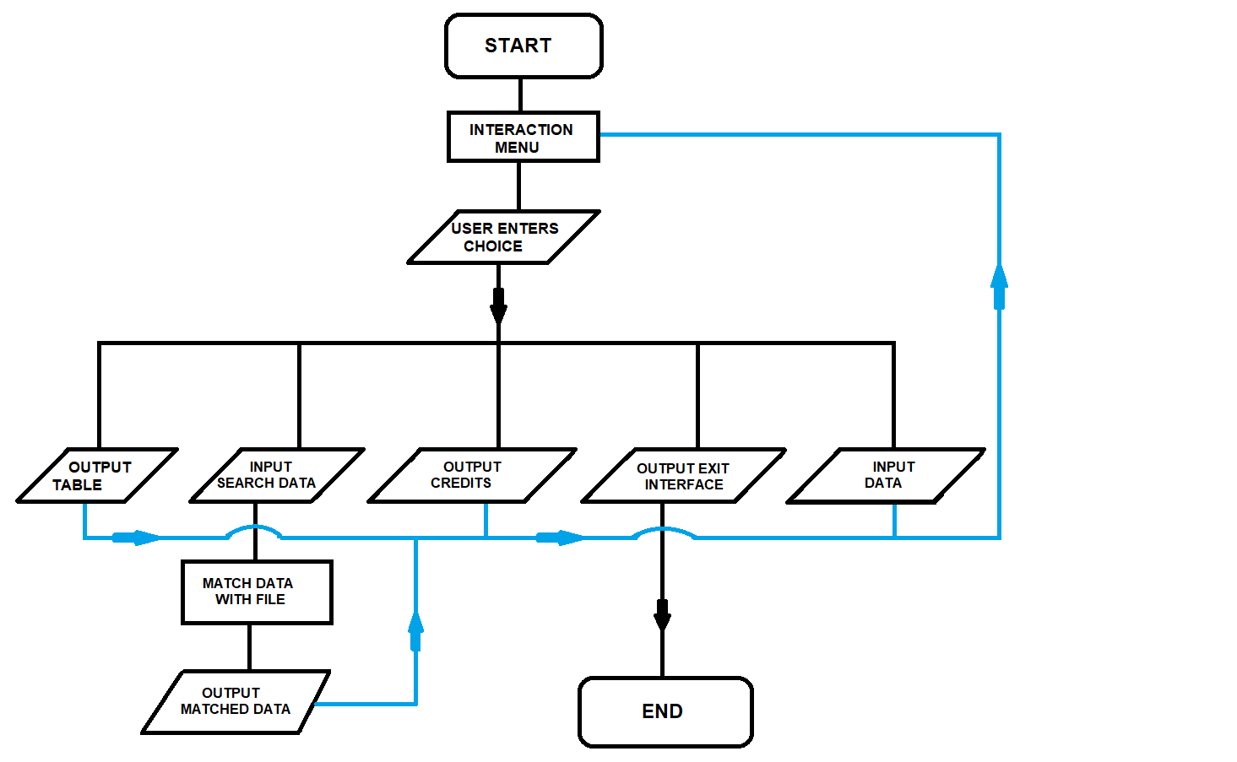

DATA MEMBERS AND FUNCTIONS USED

**void assign_values()**

This function assigns object variables values like the name of the element, atomic mass, period no, etc.

**void classtofile()**

This function writes object variables of class to file “p_data.dat” which then stores information of each element entered.

**void show_data()**

This function prints object variables values like the name of the element, atomic mass, period no ,etc. on the program to the user.

**void search_e_details (int )**

This function search object values stored in file “p_data.dat” according to some set of conditions given by the user. Like, find element which has name hydrogen, an element which has symbol He, etc.

**void exit_now()**

This function helps in exiting the program if the user wants to exit.

**void p_table ()**

This function helps in printing ASCII periodic table

**void matrix ()**

This function just gives matrix effect (random numbers changing pattern), this function is not so important but it looks good when the program starts.

**void credits ()**

This function prints creators or coders name on the screen.

**void menu ()**

This function prints the main menu as well as to-do options.

**void main ()**

This function initialize the class object and calls “void menu()” function.

**Data Members**

Various Data members are used to either temporarily or permanently store data about a given element, or the user’s input to search for one.

CODE OF THE PROJECT

#include<iostream>

#include<conio.h>

#include<math.h> //floor function

#include<fstream>

#include<string.h>

#include<stdlib.h> //exit

using namespace std;

void matrix(void);

void exit(void);

int menu(void);

void credits(void);

//+++++++++++++++++++++++++++++++++++++++++++++++++++++++++++

//+++++++++++++++++++++++++++++++++++++++++++++++++++++++++++

//++++++++++++++++++++++++ CLASS +++++++++++++++++++++++++++++

//+++++++++++++++++++++++++++++++++++++++++++++++++++++++++++

//+++++++++++++++++++++++++++++++++++++++++++++++++++++++++++

class ELEMENT

{

public:

char e_name[12],e_symbol[4],e_fact[1000],e_block[2],e_nature[40];

float at_mass;

int at_no,e_group,e_period;

ELEMENT() //constructor

{

strcpy(e_name,"No Info Available");

strcpy(e_symbol,"No Info Available");

strcpy(e_fact,"No Info Available");

strcpy(e_block,"No Info Available");

strcpy(e_nature,"No Info Available");

e_group=0;

e_period=0;

at_no=0;

at_mass=0;

}

void assign_values();

void classtofile();

void show_data();

void search_e_details(int);

}a1;

void ELEMENT::assign_values()

{

cout<<"\n\n\t\t\tEnter Values...\n";

cout<<"\nEnter Element Name : ";

cin.getline(e_name,11);

cout<<"\nEnter Element Symbol : ";

cin.getline(e_symbol,3);

cout<<"\nEnter Atomic Number : ";

cin>>at_no;

cout<<"\nEnter Atomic Mass : ";

cin>>at_mass;

cout<<"\nEnter Nature : ";

cin.ignore();

cin.getline(e_nature,30);

cout<<"\nEnter Period Number : ";

cin>>e_period;

cout<<"\nEnter Group Number : ";

cin>>e_group;

cout<<"\nEnter Block : ";

cin>>e_block;

cout<<"\nEnter Element Facts : ";

cin.ignore();

cin.getline(e_fact,999);

cout<<"\nPress Any Key To Continue...";

getch();

}

void ELEMENT::classtofile()

{

ofstream datafile;

datafile.open("P_data.dat",ios::app);

datafile.write((char*)this,sizeof(*this));

datafile.close();

}

void ELEMENT::show_data()

{

cout<<"\n\n\t\t\t\t\t...ELEMENT DATA...\n";

cout<<"\n\n\t\t\tElement Name : ";

cout<<e_name;

cout<<"\n\n\t\t\tElement Symbol : ";

cout<<e_symbol;

cout<<"\n\n\t\t\tAtomic Number : ";

cout<<at_no;

cout<<"\n\n\t\t\tAtomic Mass : ";

cout<<at_mass;

cout<<"\n\n\t\t\tNature : ";

cout<<e_nature;

cout<<"\n\n\t\t\tPeriod Number : ";

cout<<e_period;

cout<<"\n\n\t\t\tGroup Number : ";

cout<<e_group;

cout<<"\n\n\t\t\tBlock : ";

cout<<e_block;

cout<<"\n\n\t\t\tElement fact : ";

cout<<e_fact<<endl<<endl;

cout<<"Press Any Key To Continue...";

getch();

}

//+++++++++++++++++++++++++++++++++++++++++++++++++++++++++++

//+++++++++++++++++++++++++++++++++++++++++++++++++++++++++++

//++++++++++++++++++ SEARCH FUNCTION +++++++++++++++++++++++

//+++++++++++++++++++++++++++++++++++++++++++++++++++++++++++

//+++++++++++++++++++++++++++++++++++++++++++++++++++++++++++

void ELEMENT::search_e_details(int choice=0)

{

int data_flag=0,atno=0;

ifstream datafile;

datafile.open("P_data.dat");

if(choice==2) //ATOMIC NUMBER

{

cout<<"\n\nEnter Atomic Number : ";

cin>>atno;

datafile.read((char*)this,sizeof(*this));

while(!datafile.eof())

{

if(at_no==atno)

{

data_flag=1;

show_data();

break;

}

else

datafile.read((char*)this,sizeof(*this));

}

}

if(choice==3) //ELEMENT NAME

{

char name[21];

strcpy(name,"No Data Available");

cin.ignore();

cout<<"\n\nEnter Element Name : ";

cin.getline(name,20);

datafile.read((char*)this,sizeof(*this));

while(!datafile.eof())

{

if(strcmpi(e_name,name)==0)

{

data_flag=1;

show_data();

break;

}

else

datafile.read((char*)this,sizeof(*this));

}

}

if(choice==4) //ELEMENT SYMBOL

{

char symbol[4];

strcpy(symbol,"No Data Available");

cin.ignore();

cout<<"\n\nEnter Element Symbol : ";

cin.getline(symbol,3);

datafile.read((char*)this,sizeof(*this));

while(!datafile.eof())

{

if(strcmpi(e_symbol,symbol)==0)

{

data_flag=1;

show_data();

break;

}

else

datafile.read((char*)this,sizeof(*this));

}

}

if(choice==5) //ATOMIC MASS

{

float mass;

cout<<"\n\nEnter Atomic Mass : ";

cin>>mass;

datafile.read((char*)this,sizeof(*this));

while(!datafile.eof())

{

if(floor(at_mass)==mass||at_mass==mass)

{

data_flag=1;

show_data();

break;

}

else

datafile.read((char*)this,sizeof(*this));

}

}

if(choice==6) //GROUP AND PERIOD NUMBER

{

int group=0,period=0;

cout<<"\n\nEnter Group Number : ";

cin>>group;

cout<<"\n\nEnter Period Number : ";

cin>>period;

datafile.read((char*)this,sizeof(*this));

while(!datafile.eof())

{

if(e_group==group&&e_period==period)

{

data_flag=1;

show_data();

break;

}

else

datafile.read((char*)this,sizeof(*this));

}

}

if(data_flag!=1)

{

cout<<"\n\n\n\t\t\t\t\tNo Data Available...\n\n\nPress Any Key To Continue...";

getch();

}

datafile.close();

}

//+++++++++++++++++++++++++++++++++++++++++++++++++++++++++++

//+++++++++++++++++++++++++++++++++++++++++++++++++++++++++++

//++++++++++++++++++ GRAPHIC FUNCTIONS +++++++++++++++++++++++

//+++++++++++++++++++++++++++++++++++++++++++++++++++++++++++

//+++++++++++++++++++++++++++++++++++++++++++++++++++++++++++

void exit_now()

{

cout<<"\n\n\nExiting...";

matrix();

exit(0);

}

void p_table()

{

char c;

ifstream in("p.txt");

cout << "\n\n";

while (in.eof() == 0)

{

in.get(c);

cout << c;

}

cout<<"\n\nPress Any key To Continue...";

getch();

}

void matrix()

{

for(int a;a<9999;a++)

cout<<a;

}

void credits()

{

cout<<"\n\n\n\t\t\t\t\t----CREDITS----";

cout<<"\n\n\t\t\t Made by: Akshit Sharma";

cout<<"\n\n\t\t\t Class : XII - B ";

cout<<"\n\n\t\t\t Roll number : 12231 ";

cout<<"\n\n\n\t\t\tSubmitted To : Mrs. Meenu Katal\n\n";

cout<<"\nPress Any Key To Continue...";

getch();

}

int menu()

{

int choice=0;

a:

matrix();

cout<<"\n\n\t\t\t\t\t******************************";

cout<<"\n\t\t\t\t\t****** Periodic Table++ ******";

cout<<"\n\t\t\t\t\t******************************";

cout<<"\n\n\n\n\t\t1) Periodic Table";

cout<<"\n\n\n\t\t2) Search With Atomic Number";

cout<<"\n\n\n\t\t3) Search With Element Name";

cout<<"\n\n\n\t\t4) Search With Element Symbol";

cout<<"\n\n\n\t\t5) Search With Atomic Mass";

cout<<"\n\n\n\t\t6) Search With Group And Period";

cout<<"\n\n\n\t\t7) Credits ";

cout<<"\n\n\n\t\t8) Exit";

cout<<"\n\n\n\t\t9) Insert New Elements";

cout<<"\n\n\n\t\tEnter Choice : ";

cin>>choice;

if(choice<=9&&choice>=1)

{

if(choice==1)

p_table();

if(choice==2)

a1.search_e_details(2);

if(choice==3)

a1.search_e_details(3);

if(choice==4)

a1.search_e_details(4);

if(choice==5)

a1.search_e_details(5);

if(choice==6)

a1.search_e_details(6);

if(choice==7)

credits();

if(choice==8)

exit_now();

if(choice==9)

{

cin.ignore();

a1.assign_values();

a1.classtofile();

}

}

goto a;//loop to show menu

}

//+++++++++++++++++++++++++++++++++++++++++++++++++++++++++++

//+++++++++++++++++++++++++++++++++++++++++++++++++++++++++++

//++++++++++++++++++++ MAIN FUNCTION +++++++++++++++++++++++++

//+++++++++++++++++++++++++++++++++++++++++++++++++++++++++++

//+++++++++++++++++++++++++++++++++++++++++++++++++++++++++++

int main()

{

menu();

return 0;

}

BIBLIOGRAPHY

1. <https://www.geeksforgeeks.org/file-handling-c-classes/>
2. <https://www.youtube.com/watch?v=TF2-F2duY6c>
3. <https://www.tutorialspoint.com/cplusplus/cpp_object_oriented.htm>
4. Computer Science with C++ by Sumita Arora
5. Arihant All-in-One Computer Science with C++
6. <https://en.wikipedia.org/wiki/Periodic_table>